EXPERIMENT – 10 Create a Cloning of a VM and Test it by loading the Previous Version/Cloned VM using virtual box.

**Aim:**

To create a **clone** of a Virtual Machine in VirtualBox and test it by loading the cloned VM independently.

**Procedure:**

1. Open **Oracle VirtualBox** on your host system.
2. Select the **virtual machine (VM)** you want to clone.
3. Make sure the VM is **powered off** before cloning.
4. Go to **Machine → Clone** from the menu bar.
5. The **Clone Virtual Machine wizard** opens → Click **Next**.
6. Enter a **name** for the cloned VM and choose a **location** to store it.
7. Select the type of clone:
   * **Full Clone** – creates an independent copy of the VM.
   * **Linked Clone** – shares disk with the original VM, saving space.
8. Click **Clone** → VirtualBox will create the cloned VM.
9. Once the cloning process is complete, select the **cloned VM** and start it.
10. Verify that the cloned VM loads successfully and works independently from the original VM.

Output:

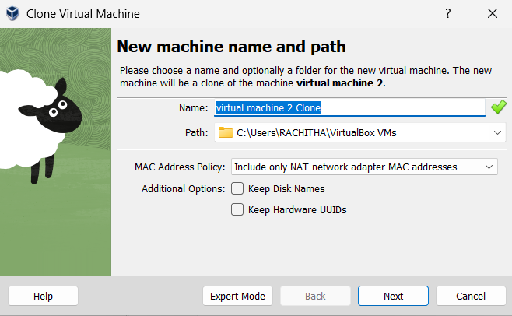

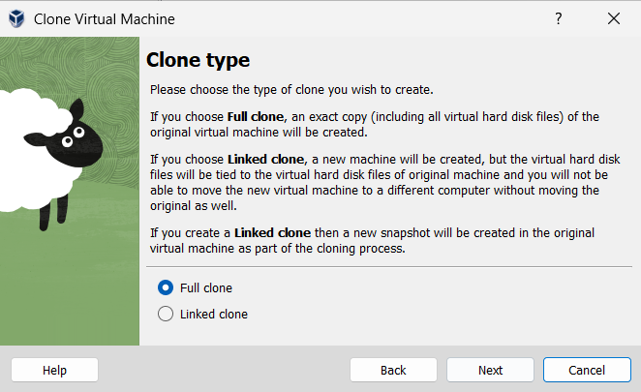

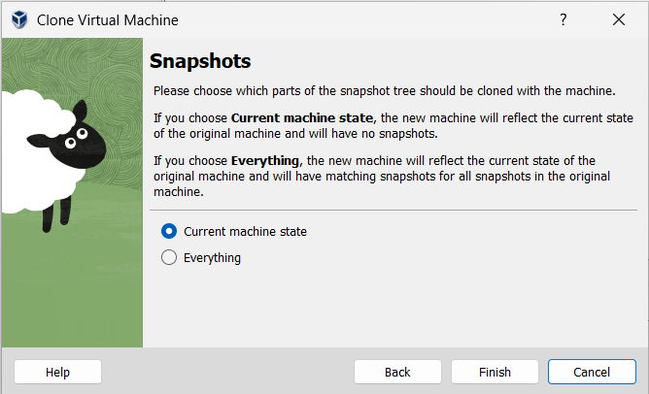

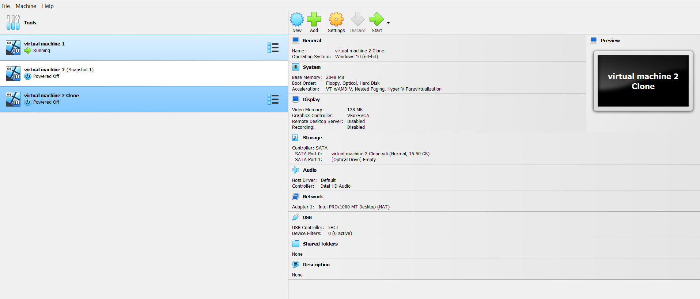

Result:

The VM was successfully cloned in VirtualBox. The cloned VM started and functioned correctly, demonstrating independent operation and the cloning feature for testing or backup purposes.